About us
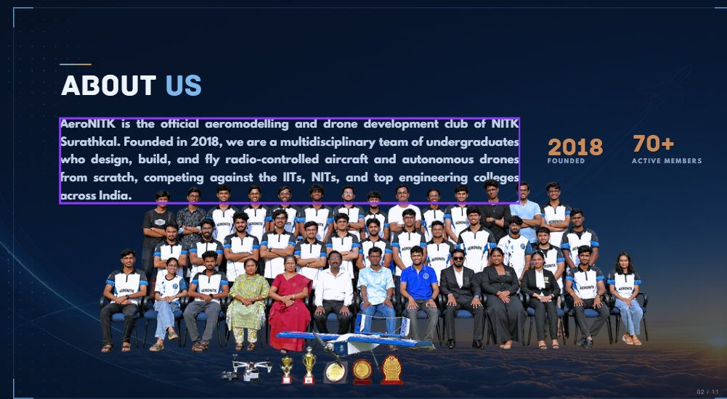
Take the content from here for About Us, then specify the numbers as mentioned below
8+ Years | 75+ Active Members | 15+ UAVs Developed | 5+ Competitions

Competitions and Events
Competition | Organizer
SAE Drone Development Challenge (SAE-DDC) | SAE Southern India Section
Autonomous Drone Development Challenge (SAE-ADDC) | SAE Southern India Section
Boeing National Aeromodelling Competition | IIT Madras
National Aeromodelling Competition | IIT Bombay TechFest
SAE Aerothon, Track 2: VTOL | SAE Southern India section
Organisers of the Wright flight event in NITK’s techfest Engineer
Organised the Boeing-sponsored workshop for students to provide hands-on experience in RC plane building.

Technical Disciplines
Aerodynamics
Conceptual aircraft design, stability analysis, CFD, and wind-tunnel testing to optimize aerodynamic performance.
Structures
Design and analysis of lightweight, high-rigidity airframes using advanced materials and composites for an optimal strength-to-weight ratio.
Avionics
Development of flight-control, sensing, telemetry, and autonomous UAV systems using automation, image processing, and machine learning.
Manufacturing
Fabrication and assembly of aircraft components using 3D printing, laser cutting, CNC machining, and other precision manufacturing processes.

Achievements
Competition | Participation / Field | Result / Position
IIT Bombay National Aeromodelling Competition – Techfest | 200+ teams across India; | Runner up
SAE– Drone Development Challenge (SAE-DDC), 2024–25 | 65+ teams | 2nd – Best Aerodynamics & CFD Analysis; 2nd – Overall Drag Performance; 5th – Most Innovative; 9th – Endurance (90 min)
SAE India – Autonomous Drone Development Challenge (SAE-ADDC), 2025-26 | 60+ teams | 3rd place for payload design
RC Plane Flying Competition – JNNCE, Shivamogga |  | Two teams from our club participated, bagging 1st and 2nd prize

